**REPORT OF THE SYSTEM**

**GENERAL DESCRIPTION OF THE LANDING PAGE:**

1. **UPPER SECTION:**

The upper section is the navigation bar which contains the name of the website that is Lesgram, the search bar that helps one search for people, events and posts by other people. It also contains the create button the when clicked helps one create a new post plus the user’s profile picture on the extreme right.

1. **MAIN SECTION:**

This comprises of three section placed in a container i.e. the left section, the middle section and the right section.

* **The left section;**

This contains a menu item that contains the home, notifications, explore, messages, the theme bar and the settings bar. The first child is the handle of the account owner and the last child is the create post button that can be used to create a new story.

* **The middle section;**

This section contains the story section on top where the user can see the new posts from his friends.

Below this is an add story section where the user can add an event, feeling, or any new event happening to him or her.

The last bit of this has the posts in real content from the users of the website especially those who are friends to the user and from the pages the user follows. This helps the user see what’s happening around the world and to his friends as well.

* **The right section;**

The right section has a search bar where the user can search for new messages. It also contains the section where one can view friend requests and also new messages received.

**SIDEBAR** **MENU-ITEM:**

We used the function below to add on the sidebar menu-item, whereby the clicked item gets the active class while other items get hidden:

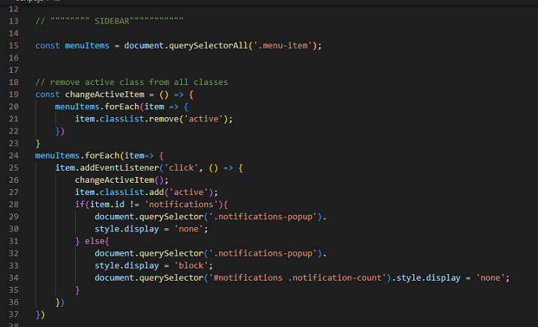

**MESSAGE SEARCH:**

A user can search for a particular message from many chats by typing the sender’s name in the message search bar and this pseudocode helps one to see only the particular message he has searched for;

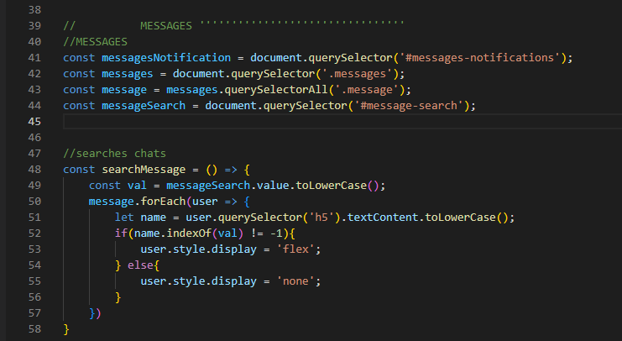

**MESSAGE NOTIFICATION COUNT DISPLAY ON THE SIDEBAR:**

The following pseudocode was used to remove the message count on the left sidebar whenever clicked;

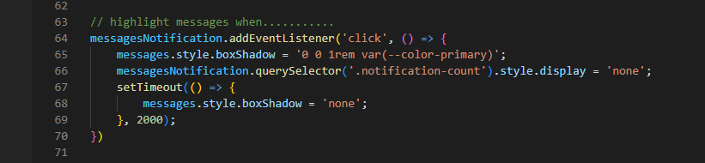

**THEME CUSTOMIZATION:**

The function openThemeModel and closeThemeModel are used to open and close the theme customization window where one can change the theme of the display in a page. The theme item can be clicked from the sidebar menu item where one is able to change the background color, the font size and the primary colors;

The function closeThemeModel helps one close the theme customization bar by clicking outside its boundary.

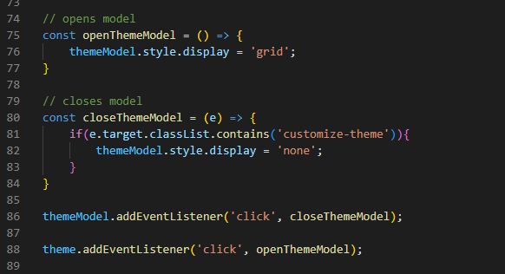

**FONT SIZE:**

The JavaScript pseudocode below allows one to change the font-size of the page where one is selected at a time. This is also included in html which goes back to the default after all is done.

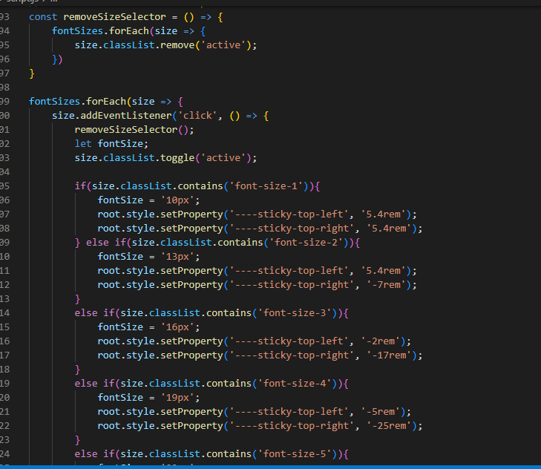

**THEME** **BACKGROUND VALUES:**

These are set to change whenever one changes the theme in order for the words to be visible to the user. They are from the classes of bg-1, bg-2 and bg-3.

The following functions and methods were used;

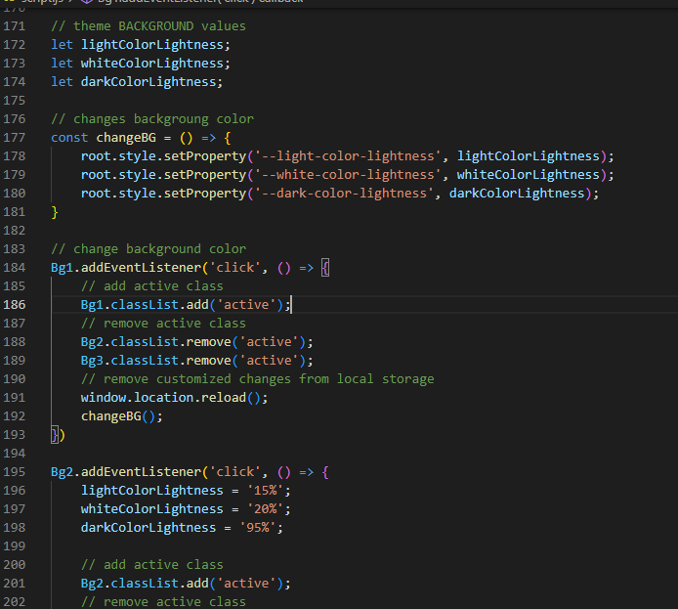

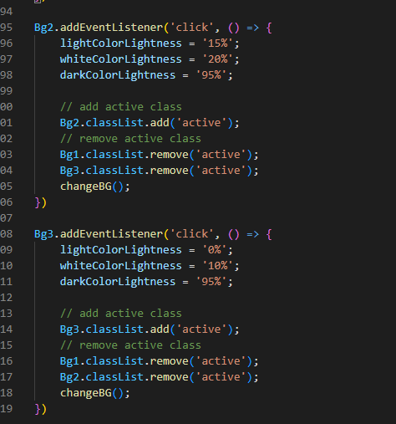

**METHODS USED** **ON THE LANDING** **PAGE JAVASCRIPT:**

* indexOf method in the message search function to look for the occurrence of the name of the user being searched for.
* toLowerCase method to help turn all the letters to lower case in the search bar of the messages as one searches for messages.
* 